**NEOPLANT NATUR FAMILY OF COSMETICAL PRODUCTS**

**About us:**

The ***NEOPLANT natural cosmetical products are*** a patented hungarian brand developed by the Neo- Plant Research and Development Kft. , which was founded in 2011and has the above mentioned licences

Address: 31/b St Olt Budapest 1112 Hungary

Phone number 36-1-786-7854

cell phone: 36-20-442-3059

Skype: dpkati1

**Websites email adresses, ordering informations :**

neoplant.org, pikkelysomor-ekceme-korpa.hu [neoplant.kft@upcmail.hu](mailto:neoplant.kft@upcmail.hu)

**PRODUCTS :**

**NEOPLANT NATUR FAMILY OF COSMETICAL PRODUCTS ARE THE NEXT:**

**NEOPLANT Skincare Cream**

**NEOPLANT Shampoo**

**NEOPLANT Aftershave**

**NEOPLANT Lotion**

The NEOPLANT products are improving the state of the skin and are taking part in the regulation of the normal metabolic processes of the skin.

Followingthe use of the Neoplant cosmetics, undesirable skin problems are annihilated or soothed, theskin regains its elasticity, flexibility. The Neoplant cosmetics also positively influence the

water content of the skin. They help in case of problems like peeling skin, dry skin, acnes,

inflammations, ulcers. The use of Neoplant is suggested in case of eczema, ulcer, rashes and

inflammatory skin problems.

The advantage of the NEOPLANT family of cosmetic products as compared to other cosmetic products are the following:

***1. They contain natural antibiotic, regenerative and soothing ingredients of plantar***

***origin***

***2. They have no harmful side-effects***

***3. They can be used my both women and men***

***4. They contain no additives, such as dyes, preservatives and perfumes***

***5. They can be used for an unlimited period of time***

***6. They are comparably very inexpensive***

**References**

**Domestic:Bellis Health Store Ltd, Herba House , Medi- Line Ltd, Bijo Food Store Ltd, Varga Reform Food house, Hungaropharma Ltd**

**1.THE NEOPLANT SKINCARE CREAM WITH REGENERATING AND**

**MOISTURIZING POWERS**

*For both women and men*

*Free from dyes and perfumes*

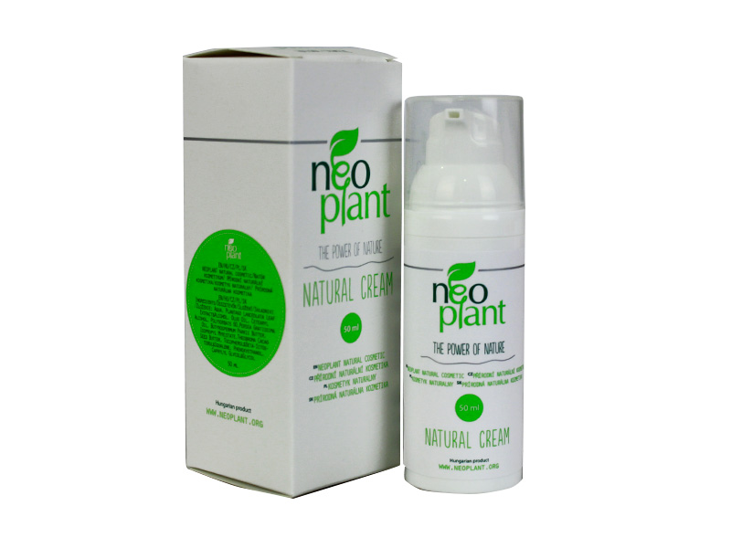

The ***NEOPLANT Skincare Cream*** has a rejuvenating and regenerating effect due to its high

carotene, vitamin C, chlorophyll content and other active ingredients of plantar origin. The

product contains exclusively natural active ingredients of plantar origin. No dyes and

parfumes!

The use of the Neoplant cosmetics in case of an inflamed, dry, or peeling skin produces a

spectacular improvement in the state of the skin.

Due to the use of the Neoplant cosmetics the skin becomes smooth, it regains its elasticity and

water content. The inflammations, itches, and rashes vanish, the regenerative processes are

accelerated. When the Neoplant cosmetics are applied to a skin with scratches and small

wounds, the processes of regeneration and healing are accelerated. The Neoplant cosmetics

cold also be applied to an inflamed, irritated skin. The use of the Neoplant skincare creme is

suggested in case of eczema, rashes and ulcers. The Neoplant skincare creme is produced on a

basis of a hungarian patent.

***Ingredients:*** Aqua, Plantago Lanceolata Leaf Extract&Alcohol, Olus Oil, Cetearyl Alcohol, Polysorbate 60, Persea Gratissima Oil, Butyrospermum Parkii Butter, Isopropyl Myristate, Theobroma Cacao Seed Butter, Tocopherol&Beta-Sitosterol&Squalene, Phenoxyethanol, Caprylyl Glycol

The product contains natural active ingredients of plantar origin which are regenerating the

skin. The product is free of dyes and perfumes. The product is to be used by rubbing it on/into

a clean skin surface. Keep it in a cool and dry place. The Neoplant Skincare Creme is a natural

cosmetics. It is best before 2 years from the date of production. It is produced on the basis of a

hungarian patent.

The number of OÉTI licence: 5533/1999, 2988/2005.CPNP reference 1546645

- Brutto weight 68 g

- Netto weight:50g- Best before 2 years from the date of production

**2.NEOPLANT FACE WASH**

*For men*

*Free from dyes and perfumes*

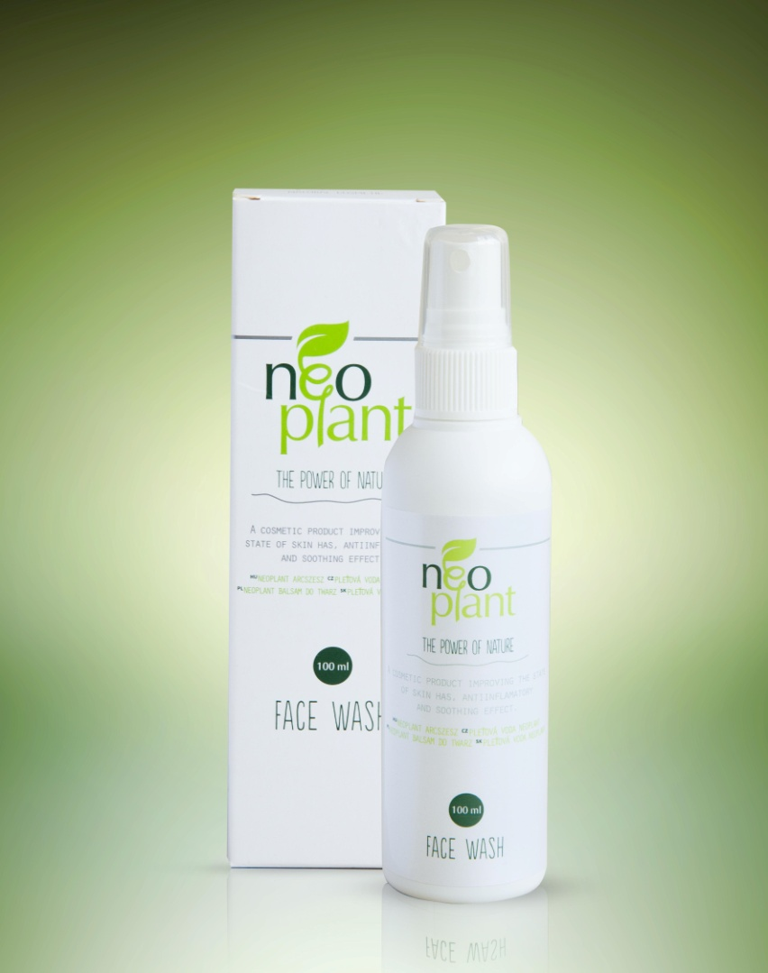

On the basis of folk remedy experiences and according to the medical literature the medicinal

plant used in this product has a natural antibiotic, styptic and regenerative effects.

The inflamed skin with acnes should be cleaned/washed with the Neoplant aftershave. The

***Neoplant face wash*** , due to its styptic and regenerative effects could also be used following

shaving on a peeling, scratched (maybe bleeding), dry skin. The use of the Neoplant

aftershave as a cosmetics is suggested in case of eczema, ulcer and inflammatory skin

problems.

***Suggestion:*** Following the use of the Neoplant aftershave Neoplant skincare creme chould be

rubbed into the skin.

***Ingredients:*** Aqua dest. Plantaginis tincture, Propilene glycol, Sorbitol, Acid. Lactic acid,

Tween 20, Aeth citri, Aeth Lavandulae, Isopropyl, Metilparahydroxi benzoicum.

- Volume: 100 ml

- OÉTI licence number: 2371/2006 CPNP reference 1546649

- Netto weight 100 gr

- Best before 2 years from the date of production

**3.NEOPLANT SHAMPOO**

*For both sexes*

*Free from dyes and parfumes*

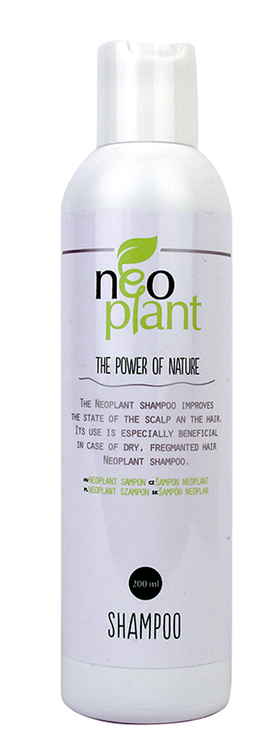

Explore the new, humane ***Neoplant Shampoo***. It clears your hair with the power of the

waterfall. It lends a silky shine to your hair. Its unique and complex active ingredients

help in maintaining the natural water content and healthy metabolism of your hair. Its

use is especially beneficial in the case of the peeling of the scalp, ongoing

inflammatory processes, dandruff, and fragmented, dry hair. The product containes

natural plantar ingredients used in folk remedies for thousands of years. The plant

extract present in the product is the active ingredient, which makes the shampoo

effective. On the basis of experiences with folk remedies and according to medical

literature, the plant extract used in this product has a natural antibiotic, styptic, and

regenerative effect.

***Suggested use:*** The NEOPLANT shampoo decreases the peeling of the scalp, and

dandruff production. It also positively affects inflammatory processes. The NEOPLANT

shampoo humanely removes all the contaminations of the scalp and hair and it is a useful co-agonist of the Neoplant lotion. The product contains the sameplant extract than the lotion and a hydrating components as well. Our hair should bewashed two times with the Neoplant shampoo. Before the second wash, the shampooshould be left on the scalp and hair for 2 or three minutes. Its use is increasinglysuggested in case of a peeling scalp, increased dandruff production, and dry

fragmented hair.

***A recommendation:*** The use of the Neoplant shampoo could be supplemented with the

use of the Neoplant lotion. Treat your scalp with Neoplant lotion before washing your

hair with the Neoplant shampoo.

***Ingredients:*** Plantaginis tincture, Cocamidopropyl betain, PEG-4, Rapeseed amine, Sodium Chloride,Lauroyl PG-Triammonium Chloride, Aeth Eucaliphti, Aeth Rosmarini.

- Volume: 200 ml

- OÉTI licence number: 2371/2006,CPNP reference:1546843

- Nettó weight: 200g

- Best before 2 years from the date of production

**4.NEOPLANT HAIR LOTION**

*For both sexes*

*Free of dyes and perfumes*

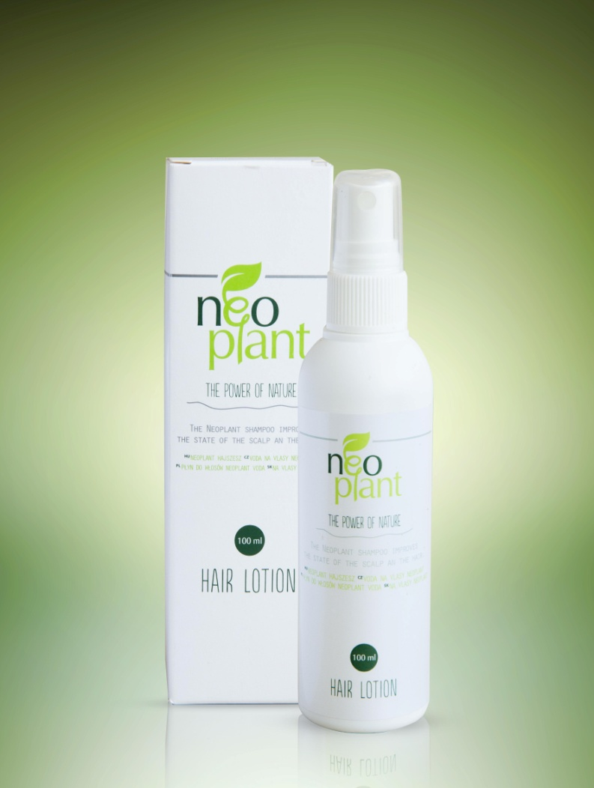

On the basis of folk remedy experiences and according to the medical literature the medicinal

plant used in this product has a natural antibiotic, styptic and regenerative effects.

The ***Neoplant Hair Lotion*** decelerates and/or prevents the inflammatory processes of the scalp.

Due to its styptic and regenerative effects it could be used on an increasingly peeling,

scratched, dry scalp. The use of Neoplant lotion is suggested for both sexes in case of the

presence of eczema, dandruff, balding, inflammatory skin problems.

The lotion should be rubbed into the scalp twice weekly, right after washing it with shampoo.

Wait until the active ingredients of the lotion diffuse into the scalp. After 20-40 minutes, you

should wash it away with water and repeatedly wash it with a shampoo.

***A suggestion:*** Before the use of the NEOPLANT lotion on the scalp we should wash hair

using a Neoplant shampoo.

***Ingredients:*** Aqua dest., Plantaginis Tincture, Menthol, lactic acid, propilene glycol,

Isopropyl, Metilparahydroxi benzoicum.

- Volume: 100 ml

- OÉTI licence number: 2371/2006, CPNP reference 1546850

- Netto weight:100 g

- Best before: 2 years from the date of production